Glider Instrumentation
Years ago Wolfgang Langweische wrote a classic book “Stick and Rudder” in which he showed how what the pilot thinks the aircraft is doing is often not what it is doing. I have set myself the more modest task of exploring what exactly is measured by aircraft instruments, and how this likely differs from what many pilots imagine. Understanding the principles of operation of the instruments upon which you depend is of interest, is important, and will lead to making better use off the information they present.
There are three instruments in the typical glider panel connected to the pneumatic system – airspeed indicator, altimeter, and vario(s). None does quite what it seems to do. The airspeed indicator does not measure or show airspeed, the altimeter does not measure or display height, and the variometer does not measure or display rate of climb. The compass, not entirely at ease in the cockpit environment where it is subject to both inertial and gravitational forces, does not always measure or show direction. There are generally two other instruments in your panel – a clock and a GPS device and both of these do what they claim to do. The yaw string is truthful, and your senses, provided you can see, are also dependable.
I have chosen to deal with the instruments in alphabetical order.
Altimeter

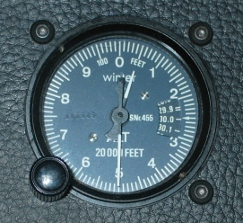

These devices don’t measure altitude, they measure pressure, and the numbers on the dial only display altitude through something approaching sleight of hand. This trick is pulled off through the use of the Standard Atmosphere. the definition of which I have taken from the AMS Glossary of Meteorology which defines the Standard Atmosphere as:
“A hypothetical vertical distribution of atmospheric temperature, pressure, and density that, by international agreement, is taken to be representative of the atmosphere for purposes of pressure altimeter calibrations, aircraft performance calculations, aircraft and missile design, ballistic tables, etc. The air is assumed to obey the perfect gas law and the hydrostatic equation, which, taken together, relate temperature, pressure, and density variations in the vertical. It is further assumed that the air contains no water vapor and that the acceleration of gravity does not change with height.“
Note that there are quite a few assumptions but what really interests us is the fact that to every pressure is assigned a unique altitude. Pressure drops as altitude increases and so a lower pressure corresponds to a greater height.
If you ever have the chance to fly in a standard atmosphere, your altimeter will actually be correct. Under all other circumstances it’s wrong, sometimes wildly so. Once it is understood that the aircraft altimeters measure pressure and have a dial indicating height, the behavior of the instrument is more transparent.
Two excellent discussions of altitude measurement may be found at:
http://mtp.jpl.nasa.gov/notes/altitude/altitude.html
http://mtp.jpl.nasa.gov/notes/altitude/AviationAltiudeScales.html

Essentially all the errors in an altimeter arise from either changes in atmospheric pressure (which can be easily corrected for), or temperature driven deviations (much harder to correct for) from the vertical profile of the standard atmosphere. These errors are generally encoded in the phrase “From high to low and hot to cold, watch out below”. I don’t much like this, it in part because it does not scan, but mostly I don’t like the idea of substituting memory crutches for comprehension. Bearing in mind that the altimeter measures pressure, not altitude and that the indicated altitude increases with decreasing pressure, it should be obvious that when atmospheric pressure drops, the altimeter reads higher. Less obvious is the effect of temperature. Recall that from the definition of the standard atmosphere, a vertical temperature profile was assumed. Since air expands when it warms and contracts when it cools, any given pressure level will rise or fall correspondingly.
The see breeze phenomenon provides an excellent illustration of the consequences of a non-standard lapse rate on pressure levels. I should start by noting that a commonly given explanation of the sea breeze is only helpful in that it depicts what does NOT happen. The argument presented is that warm air over the land rises, and cold air from the sea moves in to replace it. This explanation is often accompanied by an illustration, of which the figure below is typical:

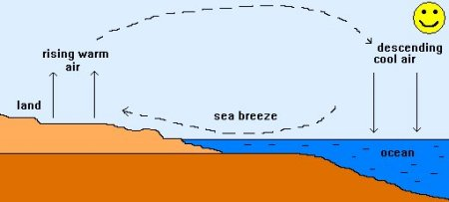.

The mechanism driving the sea breeze is more subtle and once grasped, is helpful in understanding how changes in temperature influence altimetry. In the absence of convective mixing the air being heated over the land does not, and obviously cannot rise, it simply expands, as gases always do when heated. When convection occurs, some air does indeed rise, and is quickly mixed to form the convective boundary layer with its characteristic dry adiabatic lapse rate. On balance however, the air over the land is not rising, and there is as yet no driving force for colder air over the sea to move inland. What does happen however is that the entire convective boundary layer expands and any given pressure level within it is higher than the corresponding pressure level over the ocean:

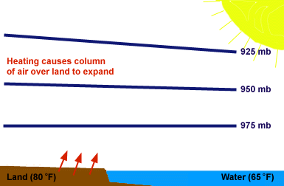

It is important to note that the pressure at the land surface has not changed – all that has happened is that the air has expanded and since the weight of a column of air has not changed, neither has the surface pressure. What does happen however is that as soon as the pressure levels are tilted, air aloft starts to flow seaward and this simultaneously causes surface pressure over land to drop, and surface pressure over the sea to increase.

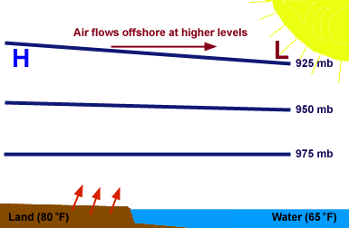

As air flows seaward a heat low develops overland, and high pressure develops offshore and the resulting pressure gradient generates the sea breeze:
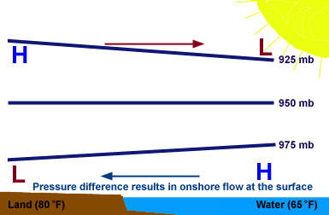

A glance at the sea breeze figure also shows why your altimeter is not to be trusted when the temperature profile of the atmosphere changes.
Departures from the standard atmosphere profile can be fatal to mountain pilots depending upon an altimeter to maintain terrain clearance but they can have consequences for glider pilots in the critical final glide phase of the flight.
Your final glide computer needs to know your energy and that energy is the sum of your kinetic energy and your potential energy. Errors in the former arise from the ASI, errors in the latter from the altimeter. Since it is necessarily the case that on a thermal mission the convective boundary layer will warm during the day, the altimeter will read low (you will be higher than it says you are) and the glideslope computer will be pessimistic as a result. On days when the pressure is also dropping, the combined error can easily be a few hundred feet. This is in some ways a good problem to have but it also means that we arrive at our goal with excess energy.
Altimeters should be set to local pressure or field altitude (QNH) as required by the FAR’s, not zero (QFE). If you share an airport with power aircraft they are going to assume that any altitude announcement is msl and if as is likely, you look at your altimeter before keying the microphone, errors are less likely with a QNH setting. A pet beef of mine is the continuing insistence of the Rules Committee on using agl not msl, and, I cannot resist adding, statute miles and statute miles per hour.
Every glider pilot should make a habit of saying “200 ft agl” on tow. I believe Tom Knauff still makes you take an extra check ride if you fail to call out 200 ft which is both a good source of revenue and a good teaching aid. It’s worth noting in this context that the altimeter lags in its response so that while climbing it always indicates low.
The altimeter is the primary indicator of cross country health. Altitude buys you options. This is a decision making sport, and when low you don’t get to make many decisions.
The instrument is useless in field landings which is one of many reasons we are taught to land a glider without reference to the altimeter. It can be helpful in airport landings (if set to QNH). It is sometimes helpful in ridge flying. There are ridges which are sneaky, and a slow change in altitude may not be apparent. Your altimeter can help, a digital one, such as is provided in some variometers and glide slope computers even more so.

ASI

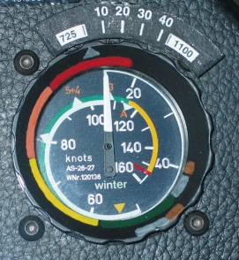

This instrument no more measures airspeed than an altimeter measures height. What it actually measures is the difference between the stagnation pressure at the tip of a pitot probe and the static pressure just behind that tip. The pressure transducer in the figure below measures dynamic pressure. The total pressure is sometimes referred to as the stagnation pressure which is the sum of the dynamic pressure and the static pressure:
S_{tagnation} = S_{tatic} + ρV²/2.

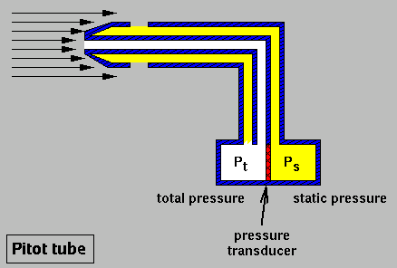

The dial of the instrument however is labeled in “mph” of “kts”. In a standard atmosphere at sea level the airspeed indicator is actually correct. Under all other circumstances it is wrong, usually by a significant amount, sometimes by a large amount.
A good case might be made for changing the numbers and labels on the face to read “inches of water” or since we are now all metric, “hPa”. There is however an excellent reason that this quaint state of affairs came about, and why it will not change so long as aircraft depend upon the properties of the air they fly in.
The aerodynamic forces acting on an aircraft are proportional to the density of the air, and the square of the speed of the aircraft. The beauty of the pitot probe is that the dynamic pressure is also proportional to the density of the air and the square of the speed of the aircraft. A moment’s thought will show that an aircraft flying at 18,000 ft will need to be going a lot faster to get the lift it needs out of the thin (less dense) air. A little more thought reveals that as pilots we cannot afford to look only at that higher speed – our aircraft stalls at the same indicated airspeed regardless of height.
It’s perhaps not so obvious why the aerodynamic forces are quadratic, not linear in airspeed. This is so because two things happen as the airspeed increase: The air molecules strike the aircraft faster, and in a given interval, more of them do so.
The difference between indicated airspeed and true airspeed can be very large indeed. A Boeing 747 cruising at about 40,000 ft has an indicated airspeed of 254 kts and a true airspeed of over 500 kts.
The very high speeds achieved at Western contests are in part due to stronger conditions, and a much deeper convective boundary layer, but an important contributory factor is the true airspeed enhancement at higher altitudes. If you cruise at 15,000 ft msl at 100 kts IAS your true airspeed is actually about 130 kts. It’s probably a good idea to bear this in mind when pulling up into a gaggle since the height gain is proportional to the square of your true airspeed, NOT your indicated airspeed and you will climb about 70% more than you would from a pull-up from say 3,000 ft in an Eastern thermal. A good rule-of-thumb is that the true airspeed increases by 2% for every 1,000 feet.
With respect to final glides, the kinetic energy of the glider depends upon the groundspeed and that is something which cannot be provided by an ASI, even in the absence of wind. Glideslope computations do calculate that true airspeed from IAS (again invoking the standard atmosphere) but a far superior approach is to use GPS data.
Airspeed is important in cross country energy management. Your polar is parabolic – if you fly ten percent faster you burn altitude 20% faster.
Keep an eye on it on fast final glides and pull-ups. VNE means what it says and there is generally very little margin.
The Clock

The two time-controlled tasks (MAT and TAT) obviously require that you keep an eye on the time. You can use a stopwatch if you like, but I pretty much guarantee you will forget to start it as you make your first (or fiftieth) contest start. I use a small clock. I necessarily keep an eye on it because the task is always opened at an announced time. Neither task requires very precise timing – you just need to be sure you don’t fly for less than the minimum time. Carry a marker with you and write down your start time. Later, when less stressed, take the time to add the minimum time to your start time and write that down too. Remember GPS clock! Every GPS device has a clock buried somewhere. Learn where it is on yours so that you never become the plaintive voice asking if anyone knows the time.
When circling, your VMG is (on average on a closed course) precisely zero. John Seymour pointed this out to me. Whenever he is tempted to flail about in weak lift he looks at the sweep second hand and feels the pain.

Compass
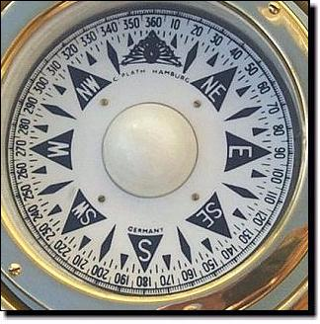

The old advice is hard to improve upon: Only in unaccelerated flight is it worth even looking at the compass. If, like me, you have a Vertical Card Compass it’s probably not worth looking at it unless you are straight and level and tapping it.
VCC versions helpful for situational awareness. I put up with the need to tap the damn thing because I still can’t look at a standard aircraft compass and figure out which way to land, or where the wind is coming from.
A compass is not nearly as useful as GPS which does a much better job (provided you are moving) of indicating direction and unless you set it to show magnetic heading (not a good idea) you don’t have to worry about variation.
Either your compass or your GPS are useful in locating other gliders – far more useful than the plaintive exchange which always seems to start with “Where are you” and end with “I don’t see you”. If two pilots establish their bearings to an agreed upon point, and their distance from that point, location is easy, or at least as easy as it’s going to get: The glider with the larger (more clockwise) bearing to the point will be to the left of the other glider and vice versa. This won’t work if one pilot has turned on the variation correction factor in his GPS and the other has not.

GOAL
300
280
/20 SM
/15 SM
GLIDER 1
GLIDER 2

Eyes



No better lift indicators than other glider – can see them five lies away, direct indication of lift strength, centering already done for you.
Eyes also useful when doing a high speed pull-up into crowded thermal.
Birds, litter, leaves, insects, clouds, haze domes. Ground features, especially anything which might generate convergence (hills, ridges, tree lines, buildings, lake boundaries).

Seat-of-the-Pants



You can’t tell a gust from a thermal, and nor can your T.E. variometer. There are good reasons for this unfortunate state of affairs which I have touched upon below under “Variometers”. On the other hand, if you can’t feel a thermal it’s probably not worth climbing in. Modern glider wings are very efficient at extracting energy from rising air. As you encounter rising air, the angle of attack abruptly increases and that of course abruptly increases the lift force. You feel this, and about three seconds after you do is a good time to turn. Why 3 seconds? On a decent day the glider is likely to be running at 80 – 90 kts as you encounter a thermal. Ninety knots is 9,000 fpm or 150 fps. You can’t expect to thermal in anything much smaller than about 900 feet diameter, so it’s going to take about 6 seconds to fly through it. There is in other words, no need to yank on the stick and put the ship into a near-vertical climb as soon as you feel something.
Not all thermal entries from high speed and far more often we have already slowed the ship in response either to our senses, or to the commands of our instruments. It is still he case however that the point to turn is almost always determined from the senses, not the instruments. You can easily feel the ship being picked up by the lift, and two or three seconds after that happens it’s time to turn. If it does not happen, there is no point in turning since neither prayers, nor hope, nor initiating a turn can produce a thermal.
Generally your senses are not helpful in fine-tuning and maintaining centering – that’s what a good vario is for but I want to emphasize that the sensing of acceleration on entering the core of a thermal is by far the best way to correctly time the turn.
Variometers

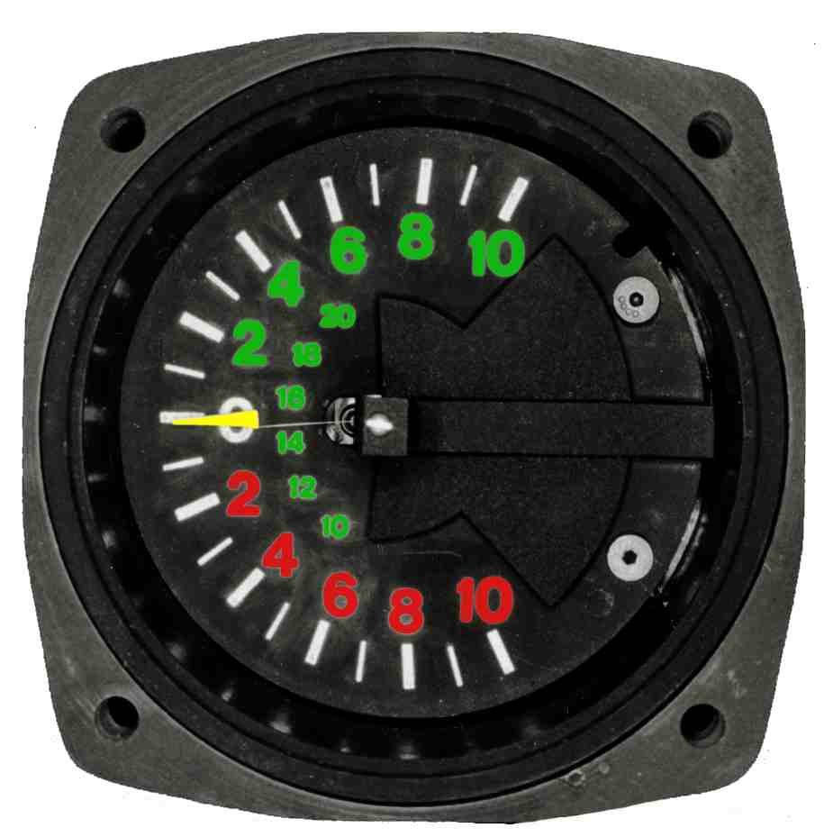

Variometers can use either flow sensing, or pressure sensing. Flow variometers require a capacity. It is the flow of air into and out of the capacity which drives the vane in a mechanical vario, or which cools a thermistor in an electric one. When using a capacity there are precautions which need to be observed: It must be thermally isolated, it should be filled with copper wool, and the connecting tubing must be as short as possible. A poorly insulated capacity will act like a sensitive thermometer and blow air out when it gets hot, or ingest air when it gets cold. Whether insulated or not, the air inside the capacity will cool as it expands, and heat as it contracts (for the same reason rising air cools, and sinking air warms). This effect introduces significant lag. By filling the capacity with copper wool, temperature changes driven by adiabatic compression and expansion are much reduced – the copper has a large heat capacity in relation to the enclosed air, it is an excellent conductor, and by virtue of its large surface area it rapidly thermally equilibrates with the air. Finally, it makes no sense to insulate the capacity, fill it with copper wool, then use ten feet of un-insulated, unfilled tubing to connect it to the instrument. The tubing generally used for this purpose has an I.D. of 3/16” so each foot of length adds a volume of about 0.2 ml. This may not sound like much, but a 10 foot change in altitude corresponds to a pressure change of about 0.03% which means a volume change for the capacity of the same amount (Boyle’s Law). The air in a 450 ml capacity will expand by 0.03% when the glider rises 10 feet and this is just 0.14 ml
T.E. Compensation
This is an ingenious, simple, and with some care, an astonishingly effective means to render the variometer insensitive to commanded changes in altitude. It is so effective that when you pull up at 2 g into a thermal, and are climbing after 1 second at almost 4,000 fpm (40 kt) your vario has an error of at most about 2 kt. It is worth taking a few moment to understand that this is not magic, but simple physics. Recall that non-T.E. varios use a static source as a reference – that is to say the capacity is on one side of the flow variometer, the static source on the other. When climbing, the static pressure drops and air flows out of the capacity, when sinking the opposite happens. This is how powered aircraft rate-of-climb meters work. If, instead of a static source, at which the pressure is simply proportional to the altitude, we could substitute a source where the pressure were proportional to the sum of the potential (height) and kinetic (speed) energy of the glider we could control the flow of air out of and into the capacity in proportion to the total energy of the glider and so eliminate “stick” thermals. Such a source is quite easy to make: A small opening on the downstream surface of a tube will generate suction when the glider is in motion, and to this suction will necessarily be added to the static pressure. (OK- “suction” is not a very scientific term but it is assumed to have a negative sign so when added to the static pressure decreases the reference pressure of the TE probe)
The suction is proportional to the square of the velocity, the static pressure to the height of the glider. Since kinetic energy is also proportional to the square of the velocity, and potential energy to its height, we have a total energy source.
Gust anomalies
Everything good comes with a price tag attached. The price we pay for T.E. compensation is gust sensitivity. It is easy to see why this must be so: Any gust which contains a component aligned with the relative wind (which is to say ALL gusts other than those which are either vertical or at right angles to the relative wind) will change suction on the T.E. probe. A gust which with a component on the nose of the glider will increase suction and cause a positive deflection on the vario. The converse is true for a gust with a component on the tail of the glider. Neither effect is small, and both make it much harder to interpret the vario reading.
Perhaps not so obvious is the fact that in exhibiting sensitivity to horizontal gusts the T.E. vario is doing exactly what it is designed to do: It faithfully measures and displays total energy. An increase in airspeed necessarily involves an increase in kinetic energy (K.E.). When you fly into a gust and the airspeed jumps by several knots your energy HAS increased. Of course when you fly out of the gust it will decrease by the same amount.
As an aside it’s a good idea to pull on encountering a gust since this allows you to extract more energy, at least it will if the gust is long enough.
Gust-induced readings are minimized by increasing the time constant of the instrument. This is why really fast varios are really useless.
Gusts come in all shapes and sizes. The really short and short ones are easily ignored, those lasting several seconds – an many do – easily fool us.
Audio
Indispensable. You cannot be looking at a needle while thermalling with other gliders. It’s also the case that while thermalling you have a good opportunity to check conditions on course, something you can’t do if staring at an instrument.
Mechanical Vario
Poor backup. If you expect to be able to remain effective following a failure in your primary vario, I strongly urge that you consider getting an audio vario backup.
Schueman (now Sage) magic. These are beautiful instruments, accurate, and easily read. I rely upon mine, as do others, in making the decision on whether to turn or not.
Glideslope Computer
Now often just part of a PDA application. A rather mixed blessing but if we want graphical displays, and most of us seem to, there is little else available. The usual dysbiosis which seems to afflict technology has resulted in the advent of competition tasks which require the use of a graphical display. Software runs the gamut from the distracting (moving map display of the ridge you are on) to the ascetic (blank screen showing airspace, task, control points and airports). It remains to be seen where this will stabilize.
You can manage speed-to-fly the way George Moffat is said to do – “I fly two speeds, slow and fast” – or you can fly McCready. If you do fly McCready it’s essential to have a device which tells you what speed to fly, preferably with audio feedback.
Final glides in modern gliders, particularly those with a tail wind, always seem certain to end far short of the goal. They are so shallow that you cannot rely upon visual clues. A decent glideslope computer is essential, and even then you probably won’t be too happy until you have learned to trust it.
GPS
It has taken an astonishingly short time for this technology to change almost everything we do. Almost all of the changes are much for the better. I remain happy however that I got my Gold Badge distance flight in pre-GPS days and had to use a map. There is something very rewarding about having your turnpoint hove into view just about where you expected it.
Map
Still useful to carry one of these. I find it difficult to make much use of a map in the cockpit unless it is small and easily managed. The kind I prepared for this school is representative of what I find to be a useful and useable.
Pre-task planning is essential for the MAT and TAT and a good map is incomparably more useful than a PDA for this task.

Radio

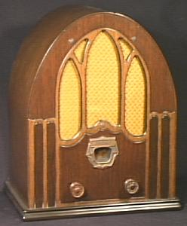

The only instrument which pays dividends for NOT using it – helps other pilots too. It’s worth reflecting that when you key the microphone you are typically broadcasting to an area of about 10.000 square miles and that not everyone is interested in the details of your imminent outlanding or your lousy thermals.
I turn mine off seconds after announcing my start and turn it on for the “QV four miles” call.
Transponder
Useful thing in the airspace I fly in but a definite PITA. Two years after installing mine the 337 process is stalled, placards are still being debated, no inspection has yet been performed and the FAA employee who initiated the process is now deceased. This is not a wholly improbable event given the tectonic pace of FAA activity.

Voltmeter

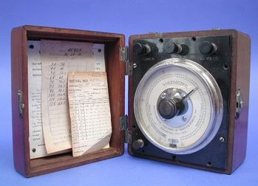

This is a surprisingly useful thing to have in the cockpit. Some instruments now come with a voltmeter built in (my radio and my vario both do) but they are often poor voltmeters to begin with, and generally do not measure battery voltage, but voltage where they happen to be.
For the type of sealed lead-acid batteries we use, the open circuit voltage is a linear indicator of remaining charge:

It should be noted that “open circuit voltage” means the voltage when no current flows. If the radio is not transmitting, the small amount of current drawn by other instruments does not significantly reduce the actual voltage below its open circuit value.
Yaw String

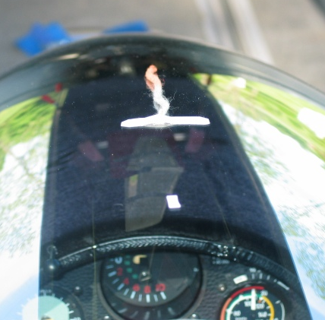

Only an alphabetical sort could put this most valuable of instruments last. It can stop you crashing and can make you fly faster, costs nothing, does not need batteries and tells the truth.
My preference is to install my yaw string out of my direct forward vision which I find helpful for other uses such as avoiding other gliders. I therefore locate it further aft where I can still see it but where it is not a distraction. To make it less likely that the string will act as though glued to the canopy its helpful to mount it in exactly the opposite manner general chosen. Finally, failure to locate it on the exact centerline of the fuselage will guarantee that you fly sideways.
When flying straight you want the string centered, when circling you want a modest slip. There are two very good reasons for this: You are much less likely to spin out of a thermal, and you will probably climb better. It’s less likely you will spin because being in a slip guarantees you won’t be in a skid,, and you will climb better because the ship will be better aligned with the relative wind because of the distortion introduced by the rather small circles we fly.

QV, April 2007

